**CS202 First Exam**

Due: 8:00 AM, 9/27/2017 Name: _Manwai Nguyen___ Score: _____________

1. (20%, Page 24, R1.18) Design a program to implement the equation below to compute the π value.

π = 4.0 * (1 - 1/3.0 + 1/5.0 – 1/7.0 + 1/9.0 – 1/11.0 + …..)

* 1. Use the WHILE loop to compute the π value, until when you have the result determined to six

Significant floating-point digits. For example: π = 3.141592 or 3.1415926.

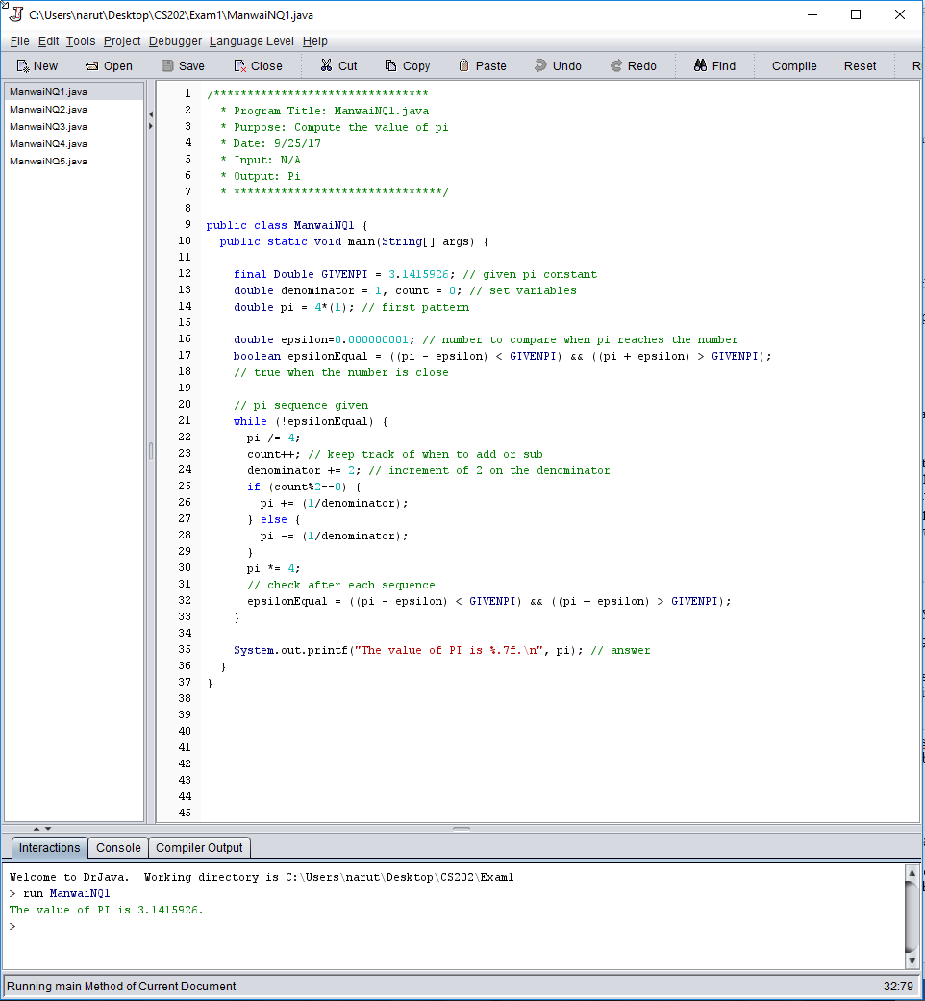1.2. Use “System.out.printf” to print your π value with at least 6 accurate floating-point digits.

1. (20%) Do programming Exercise P2.21 on page 74.
   1. Ask user to enter the following three years (one at a time) to test your program: 1997, 2007, 2017

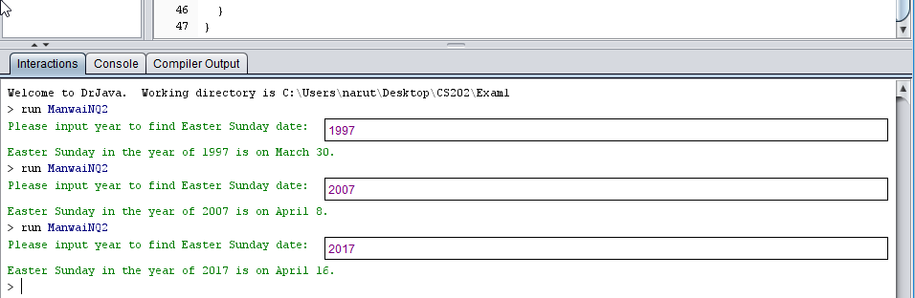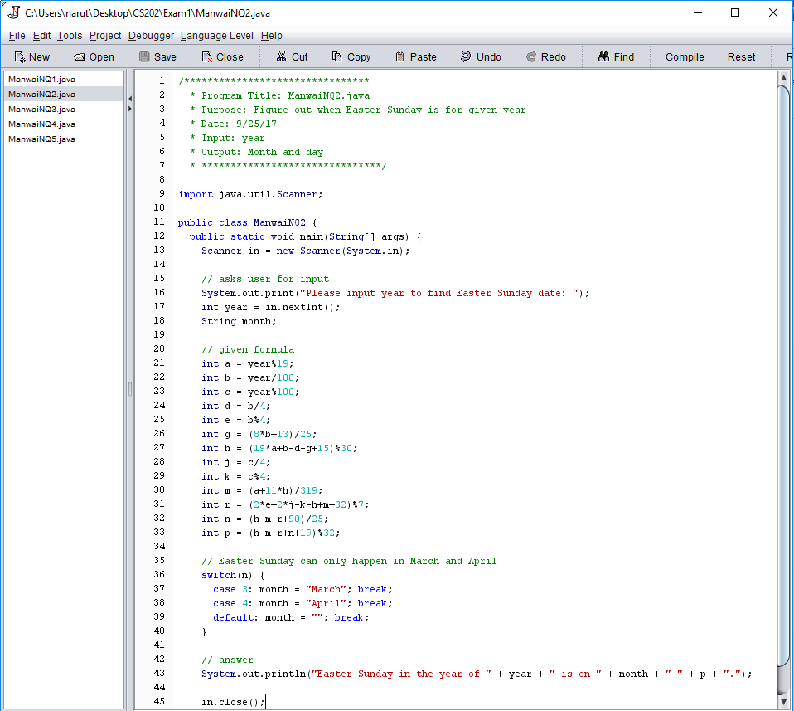2.2 Output the month and day of Easter Sunday of the input year.

1. (20%) Do Programming Exercise P3.22 on page 129. Use the following taxable incomes to test your program.

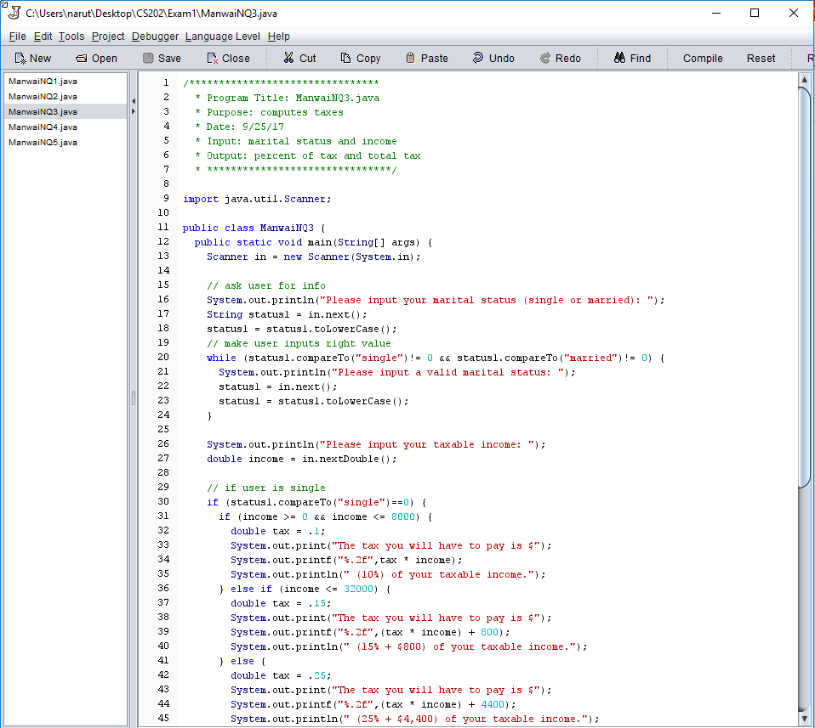 Single: {0, 8000, 8001, 32000, 32001}; Married: {0, 16000, 16001, 64000, 64001}

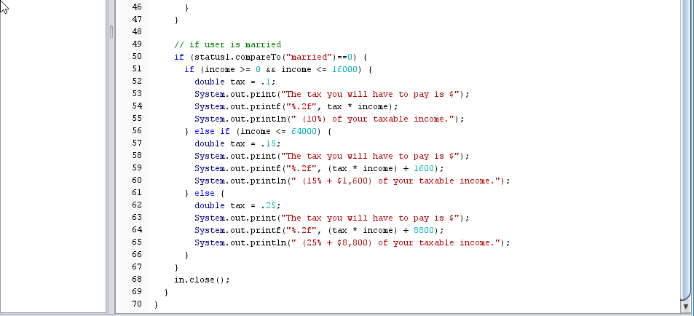

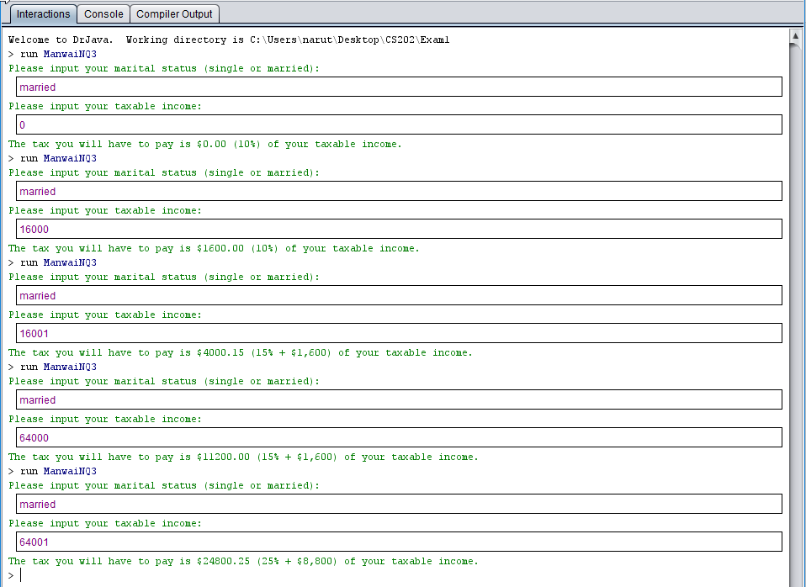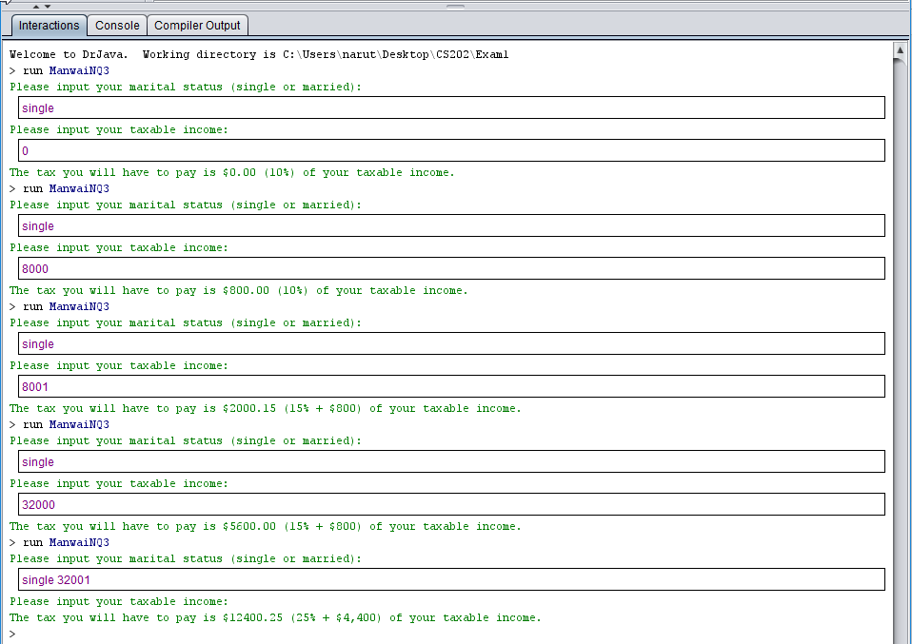

1. (20%) Do Programming Exercise P4.3 on page 188. Use the following two input strings to test your program separately {aLineOfInputAsAString ThisIsACamelHump}. Show the corresponding outputs of sub-questions {a, b, c, d, e} for each input string as below; such as for “aLineOfInputAsAString”:
2. Uppercase letters in the string are: {L, O, I, A, A, S}
3. The second letter in the string is: {L}
4. The string with all vowels replaced by an underscore is: {_L_n__f_np_t_s_Str_ng}
5. The number of vowels in the string is: 9.
6. The positions of all vowels in the string are: {1, 3, 5, 6, 8, 11, 13, 15, 19}

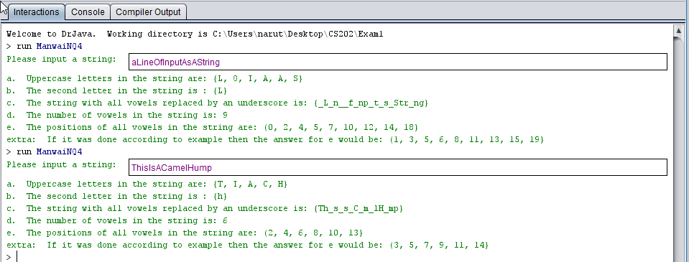

Code on next page

Note: I added both solutions for part e because I was confused on whether you wanted the standard indexing of the string or how non-computer scientist would view it.

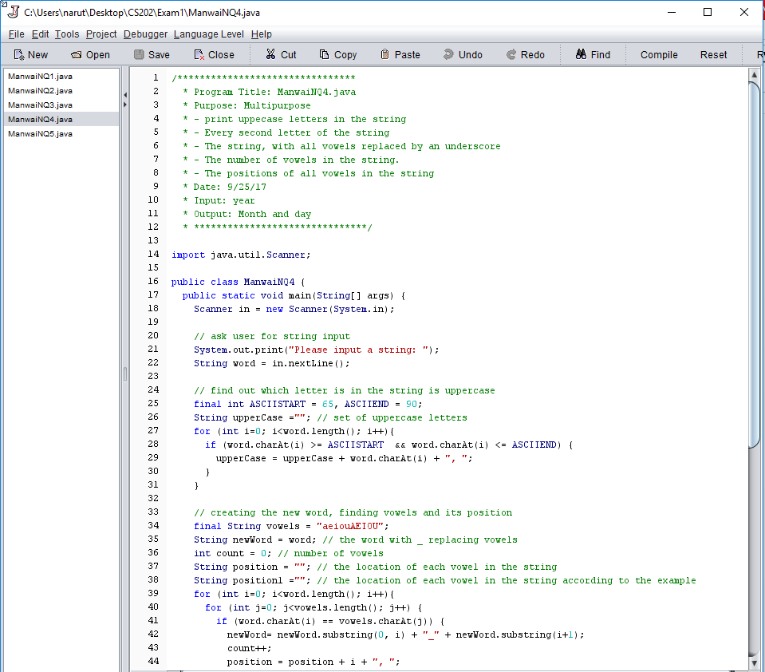

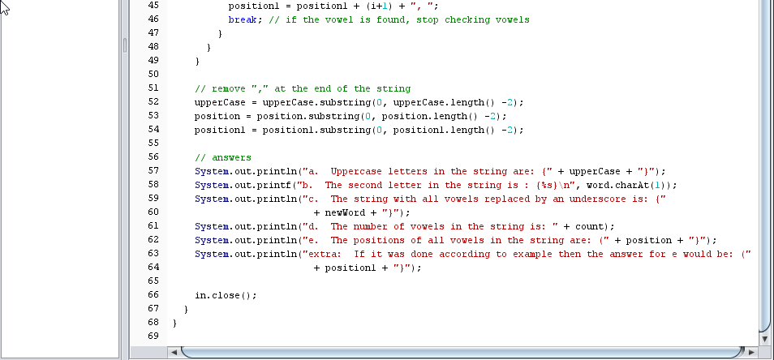

1. (20%) Do Graphics P4.38 on page 197. Also add hair, ears, eyebrows, eyes, nose, and teeth onto the face.

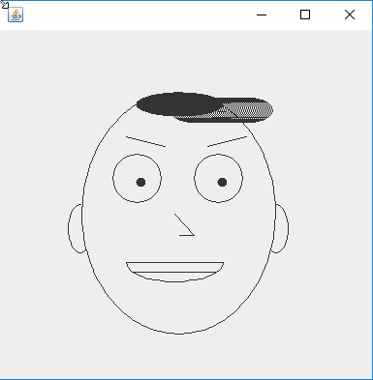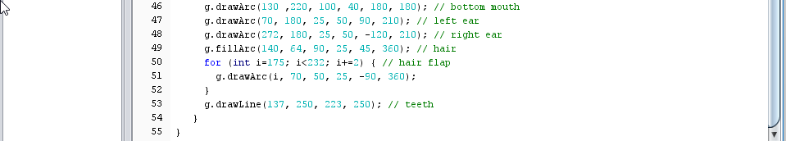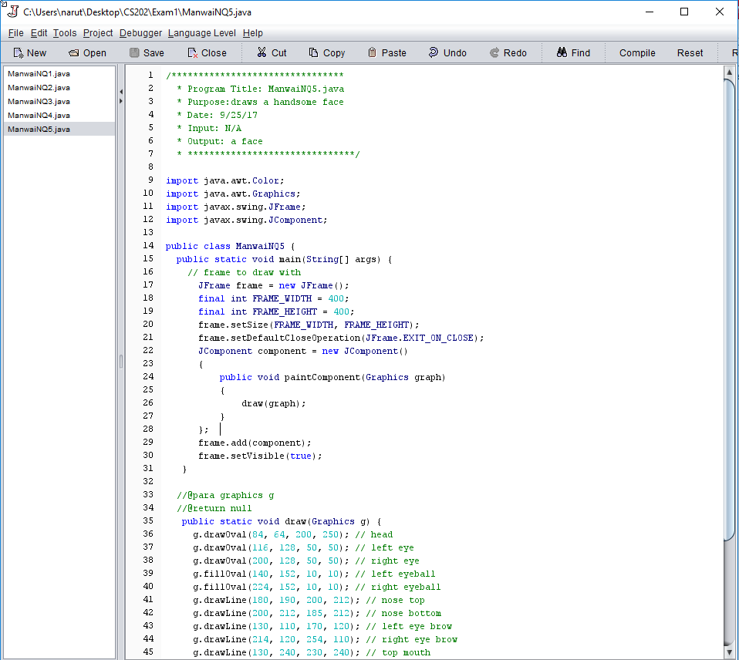Note: Use your creativity to draw the face as pretty or handsome as possible.